MINISTRY OF EDUCATION AND SCIENCE OF UKRAINE

NATIONAL TECHNICAL UNIVERSITY   
“KHARKIV POLYTECHNIC INSTITUTE”

Department of Software Engineering and Management Information Technology

REPORT

on laboratory work # 1

on the discipline

“DESIGN OF DATABASES”

Executed by

Student of the group KN-218g

chukwu irele

Checked by

Assoc. prof. of department “SEMIT”

PhD assoc. prof.

DmyTRO DVUKHHLAVOV

Kharkiv 2020

**DATABSE CREATION USING SQL LANGUAGE**

Objectives

Learn how to create and link database tables using the MySQL DBMS.

Progress of work

**Install MySQL**

For executing labs XAMPP control panel was installed . View of main window of this program presented at fig.1.

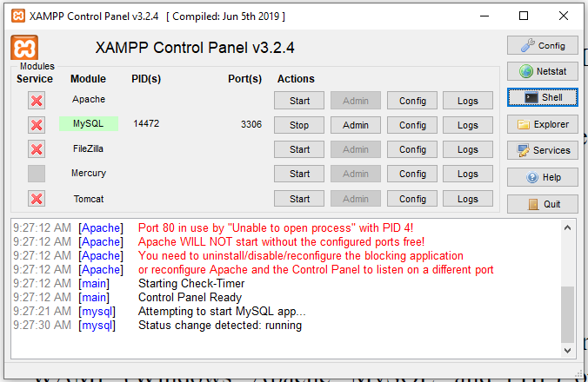

Figure 1 – XAMPP control panel

**Connect to MySQL and create a database**:

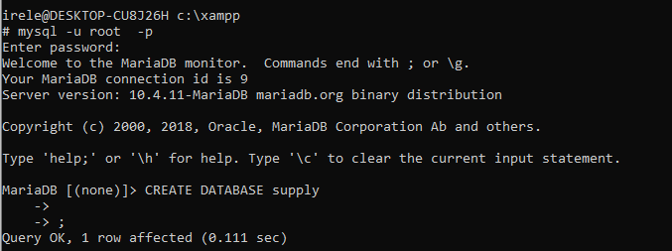

**Create database tables and link them:**

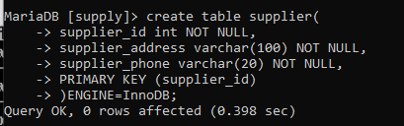

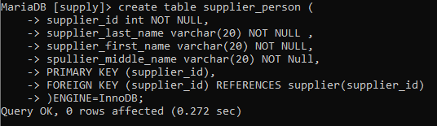

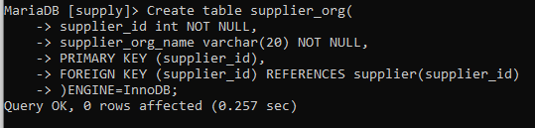

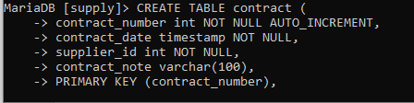

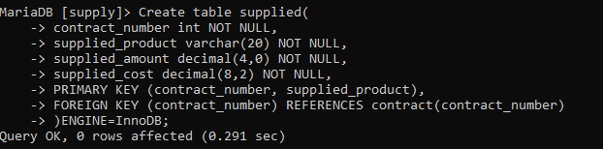

**Modification of table structure:**

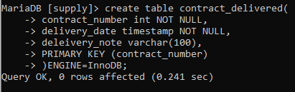

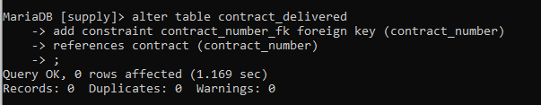

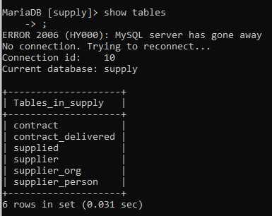

**Delete tables:**

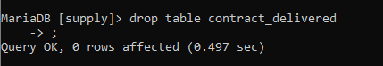

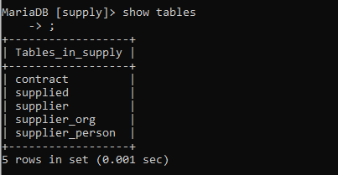

Conclusions

In conclusions:

1. I obtained skills on how to install MySQL using one of the freely distributed WAMP (Windows, Apache, MySQL, and PHP) or LAMP (Linux, Apache, MySQL, and PHP) servers, such as Open Server or XAMPP, for this laboratory and subsequent once I will be using XAMPP.
2. Obtained skills to create and connect database, show list of database on the server, show tables on the database, show columns on each table and show index from each table.
3. Also considered how to CREATE, ALTER and DELETE tables.